Nathan Hanuscin

CPE301 – SPRING 2018

Design Assignment 4

**DO NOT REMOVE THIS PAGE DURING SUBMISSION:**

The student understands that all required components should be submitted in complete for grading of this assignment.

|  |  |  |  |
| --- | --- | --- | --- |
| **NO** | **SUBMISSION ITEM** | **COMPLETED (Y/N)** | **MARKS**  **(/MAX)** |
| 1 | COMPONENTS LIST AND CONNECTION BLOCK DIAGRAM w/ PINS |  |  |
| 2. | INITIAL CODE OF TASK 1/A |  |  |
| 3. | INCREMENTAL / DIFFERENTIAL CODE OF TASK 2/B |  |  |
| 3. | INCREMENTAL / DIFFERENTIAL CODE OF TASK 3/C |  |  |
| 3. | INCREMENTAL / DIFFERENTIAL CODE OF TASK 4/D |  |  |
| 3. | INCREMENTAL / DIFFERENTIAL CODE OF TASK 5/E |  |  |
| 4. | SCHEMATICS |  |  |
| 5. | SCREENSHOTS OF EACH TASK OUTPUT |  |  |
| 5. | SCREENSHOT OF EACH DEMO |  |  |
| 6. | VIDEO LINKS OF EACH DEMO |  |  |
| 7. | GOOGLECODE LINK OF THE DA |  |  |
|  |  |  |  |
|  |  |  |  |

1. **COMPONENTS LIST AND CONNECTION BLOCK DIAGRAM w/ PINS**

1K potentiometer

DC motor

4-lead Stepper motor

Servo motor

Task1 Block Diagram:

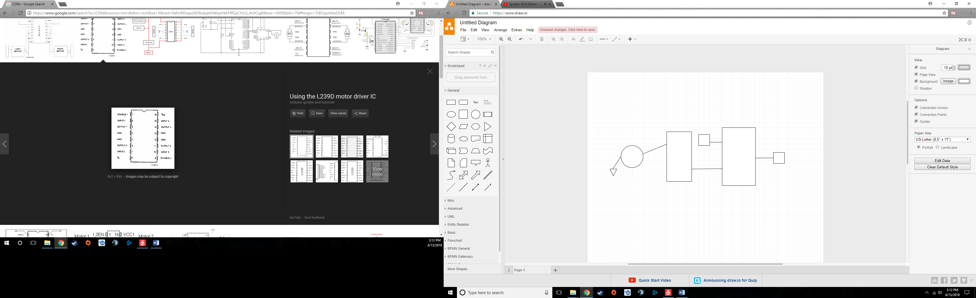

DC motor

Output1

PD2

Button

ACD value

1K Pot

ATmega328

PC0

Enable1

L239D

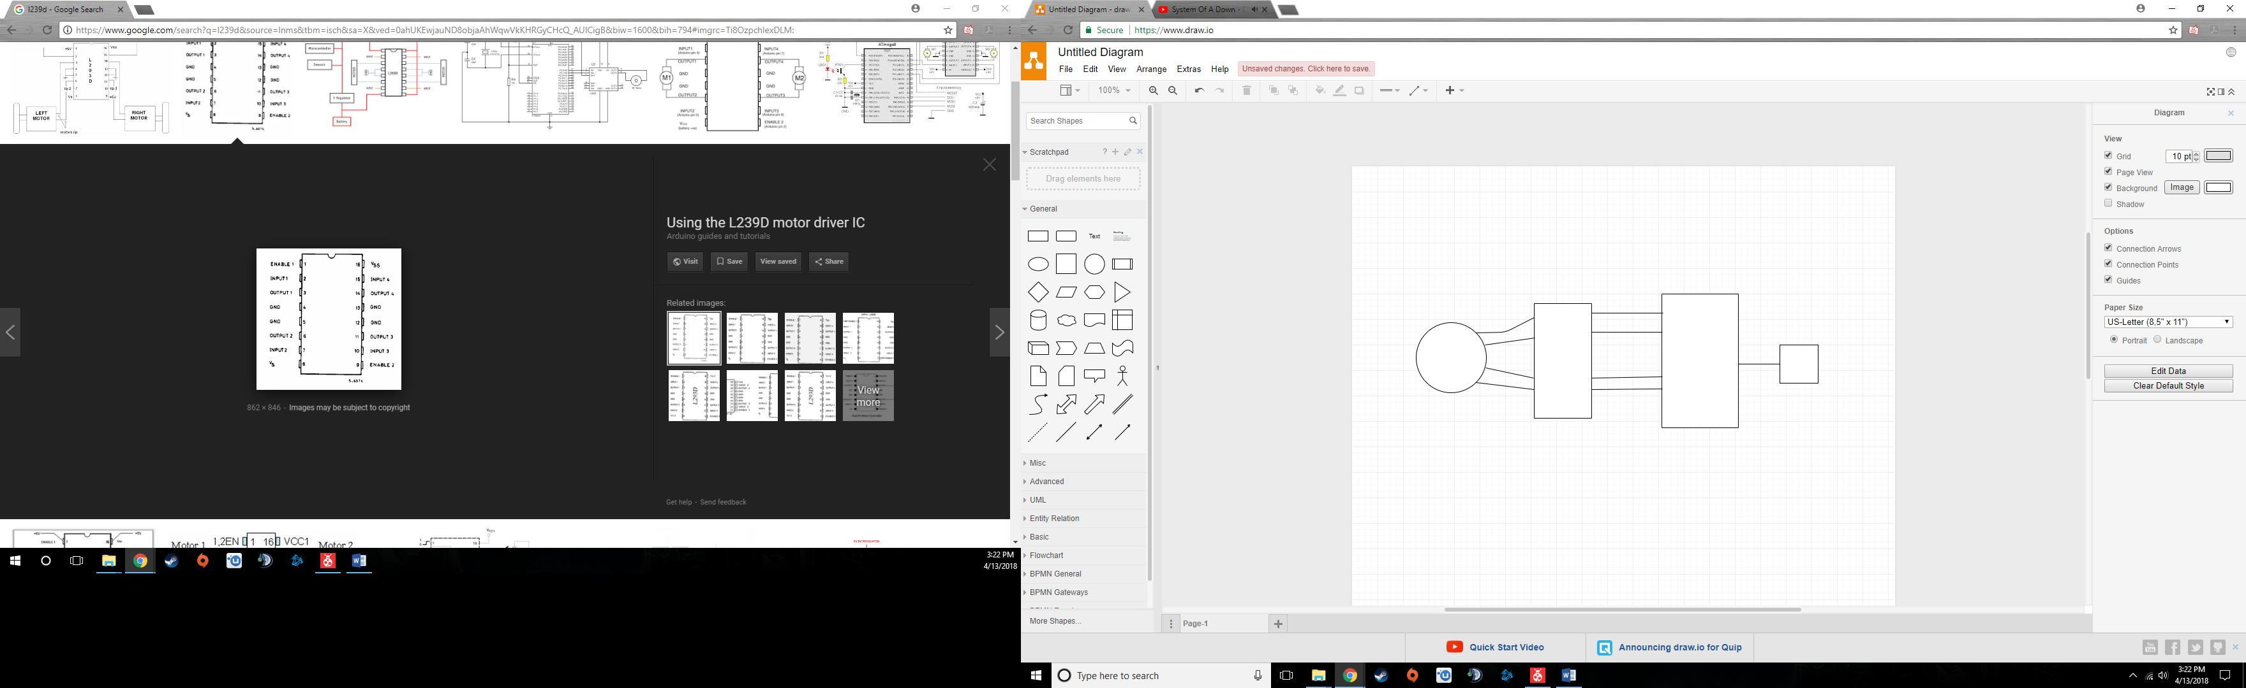Task 2 Block Diagram:

OUT4

OUT3

OUT2

OUT1

IN7

IN6

IN2

IN1

PB7

PB6

PB0

PB1

ULN2003

Stepper motor

ACD value

1K Pot

PC0

ATmega 328

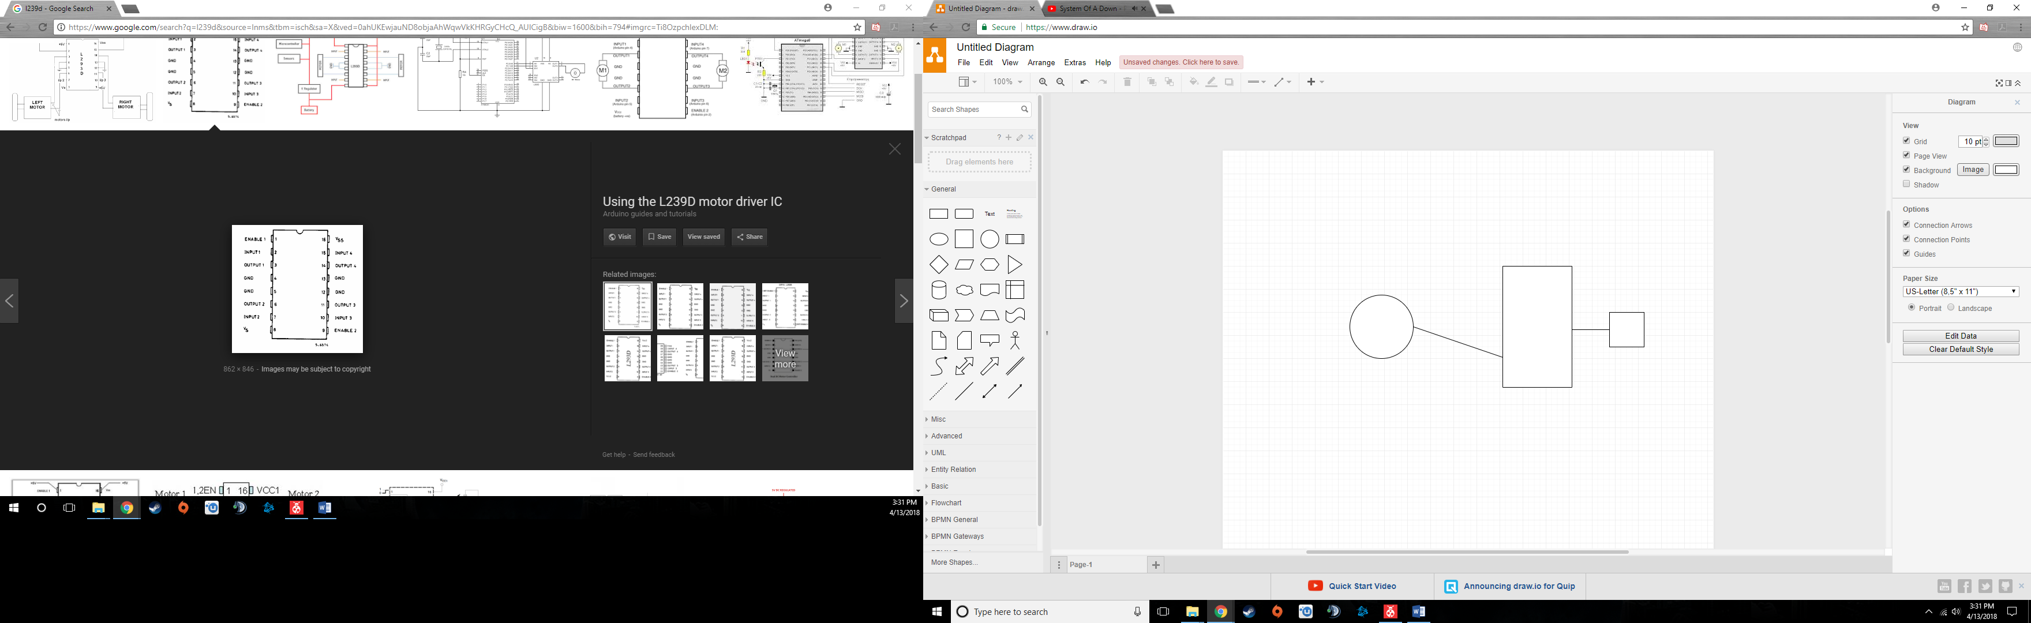Task 3 Block Diagram:

PB1

Servomotor

ATmega328

PC0

ACD value

1K Pot

1. **INITIAL/DEVELOPED CODE OF TASK 1/A**

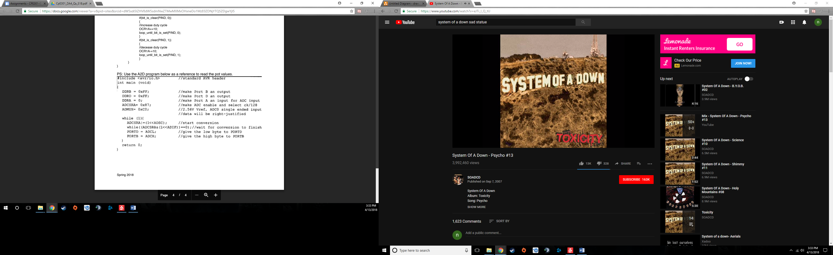

1. **INITIAL/DEVELOPED CODE OF TASK 2/B**

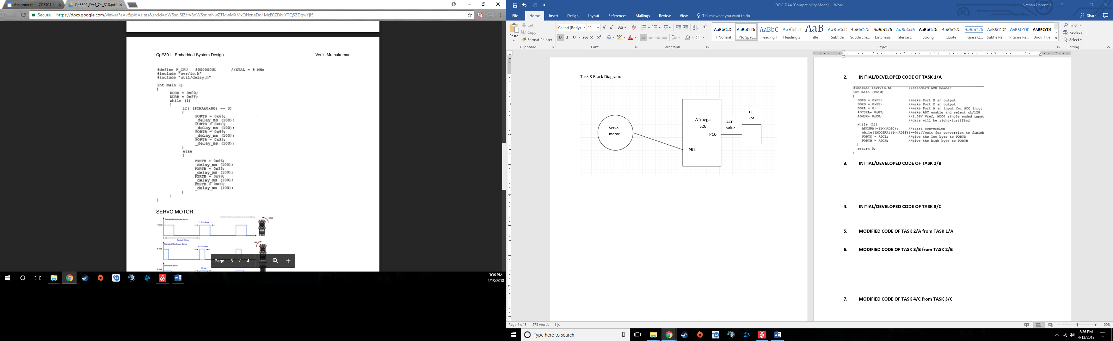

1. **INITIAL/DEVELOPED CODE OF TASK 3/C**

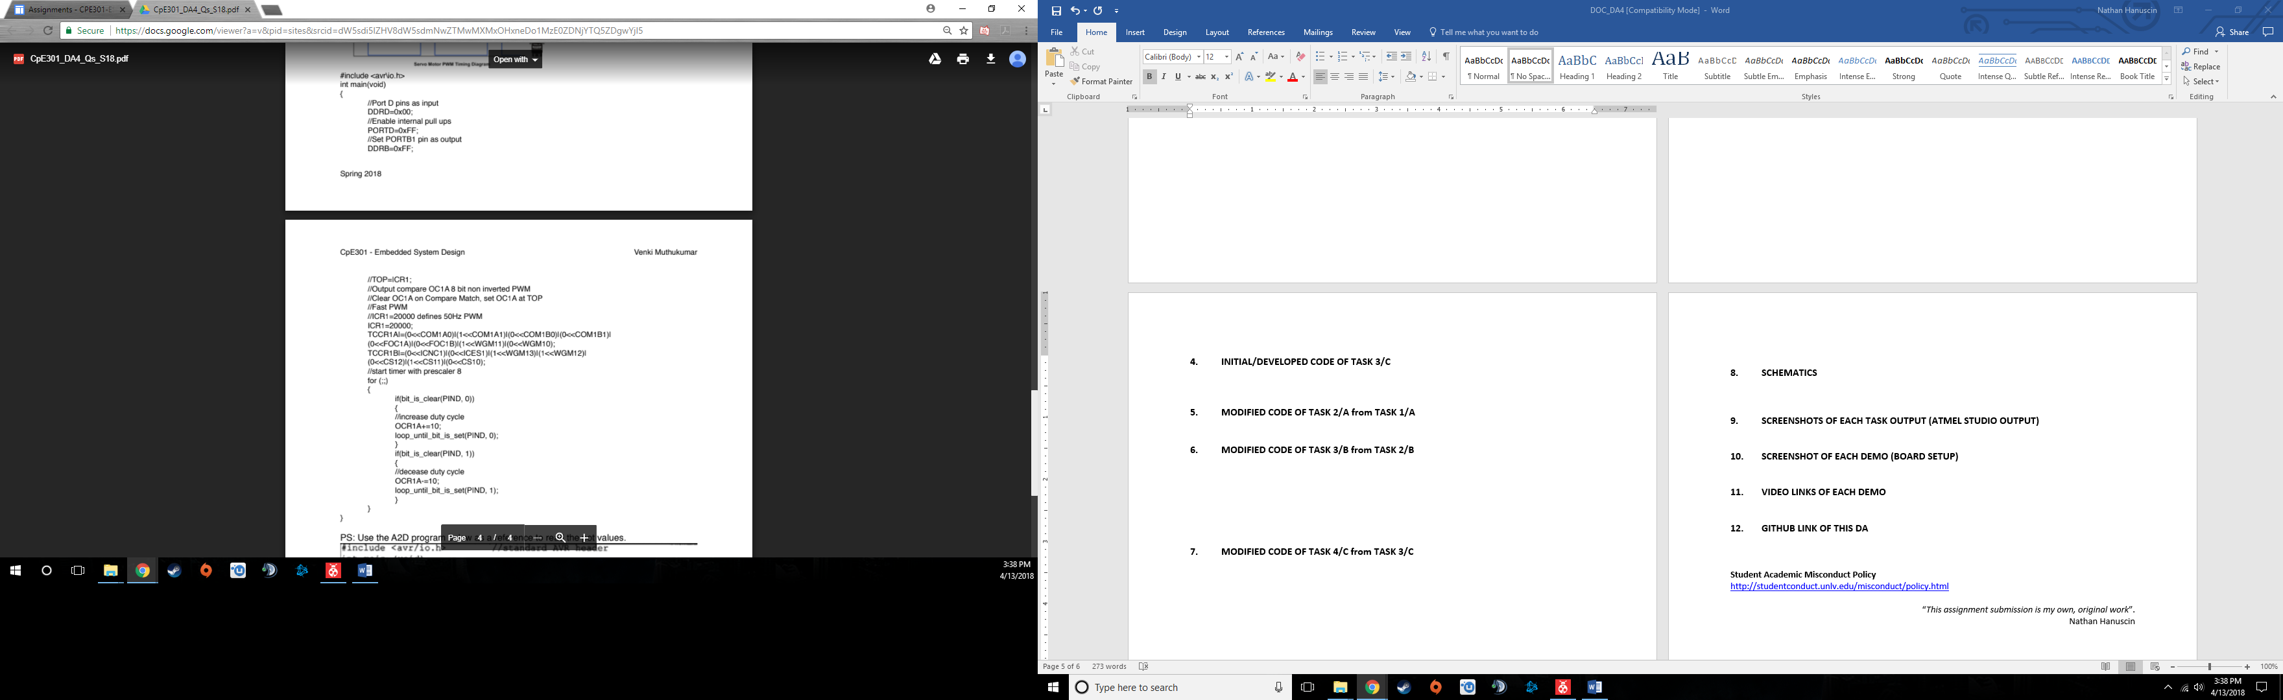



1. **MODIFIED CODE OF TASK 2/A from TASK 1/A**

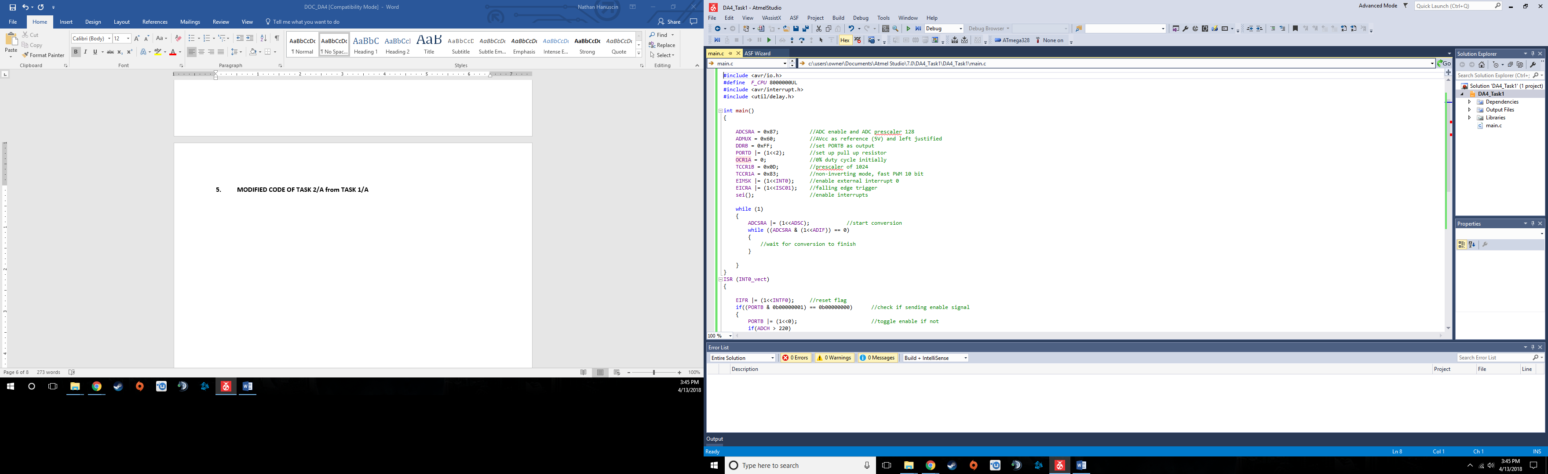

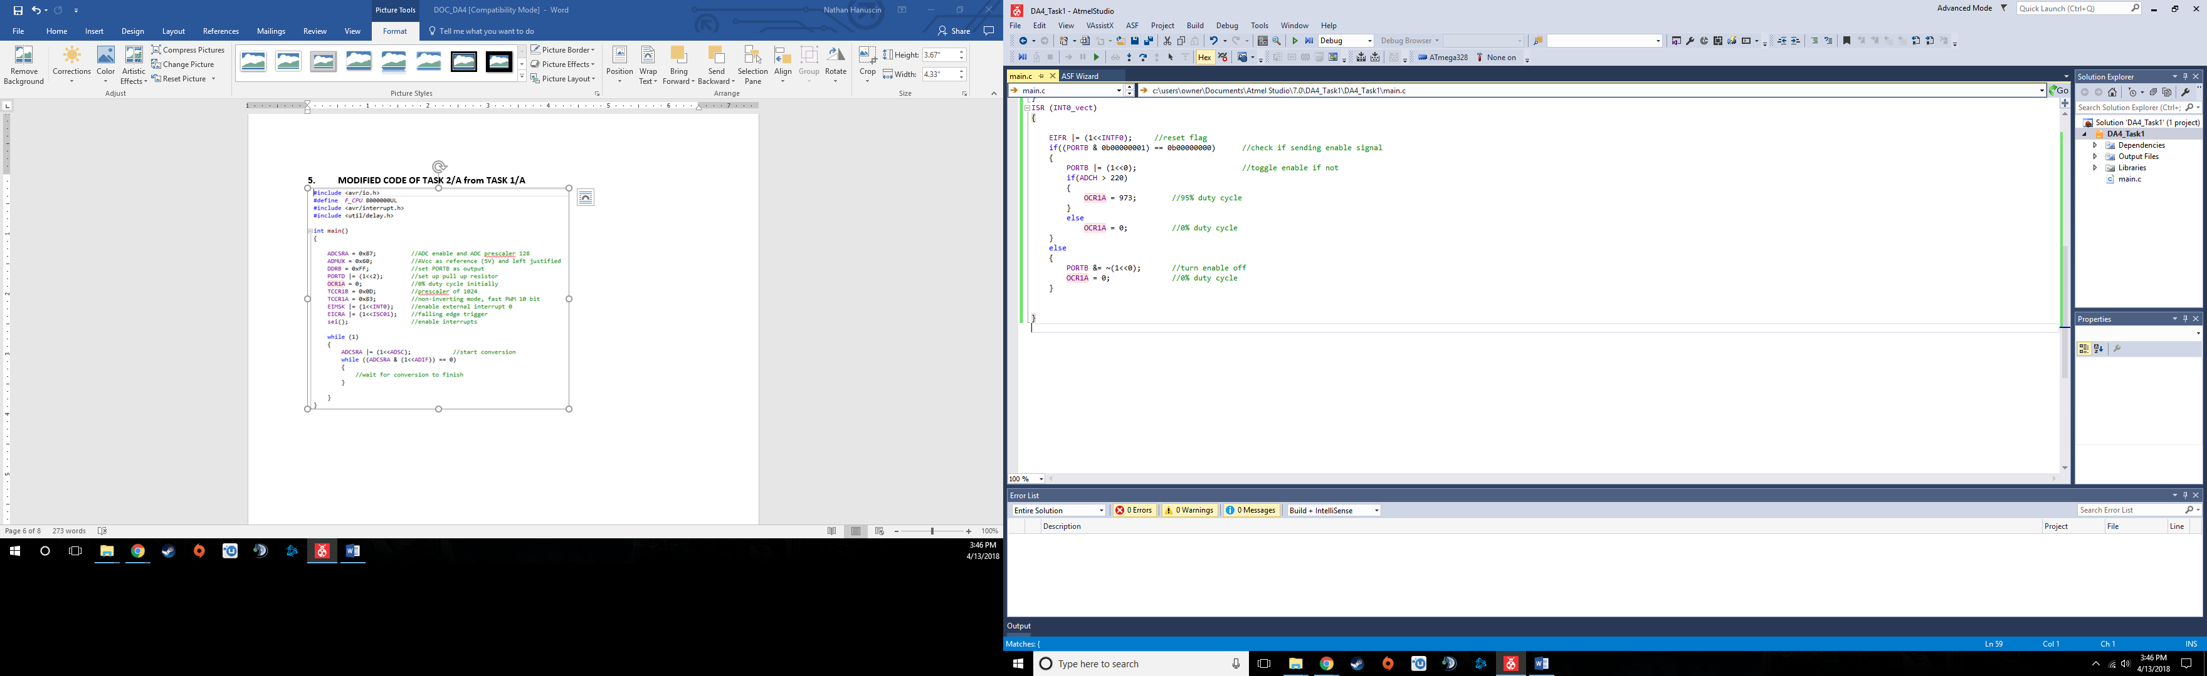

1. **MODIFIED CODE OF TASK 3/B from TASK 2/B**

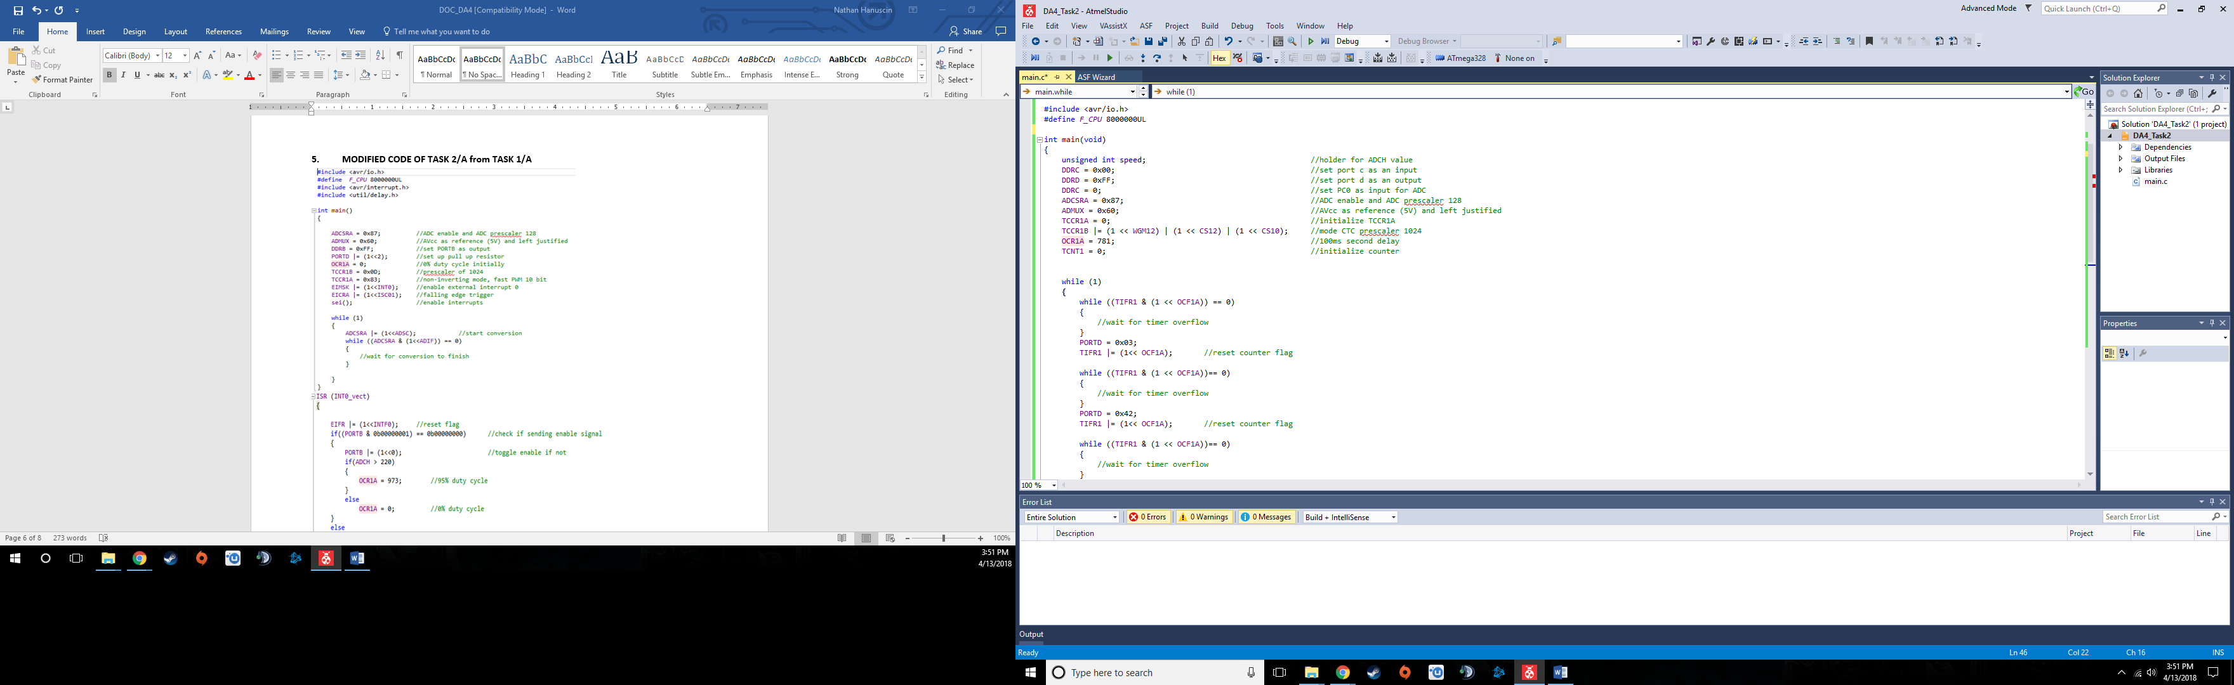

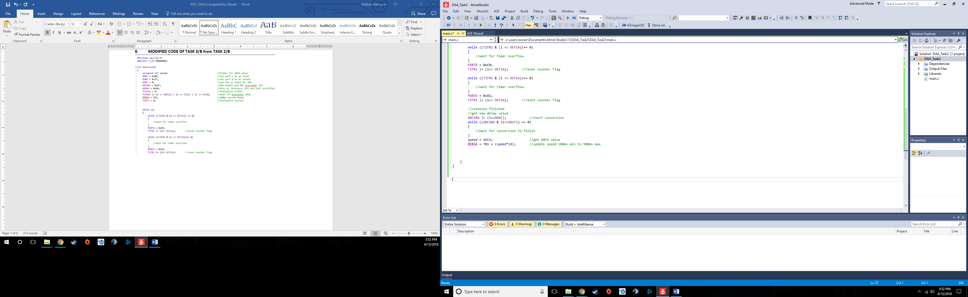

1. **MODIFIED CODE OF TASK 4/C from TASK 3/C**

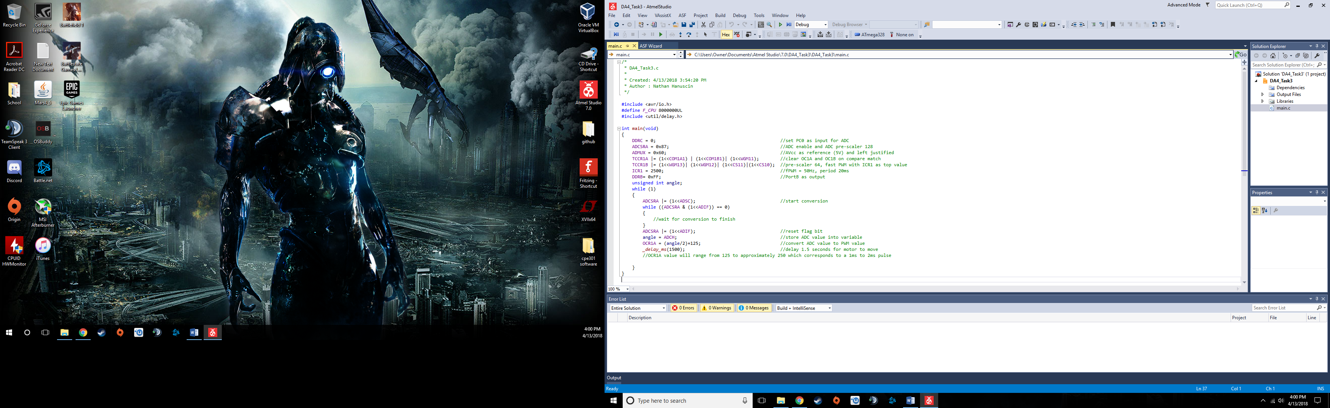

1. **SCHEMATICS**

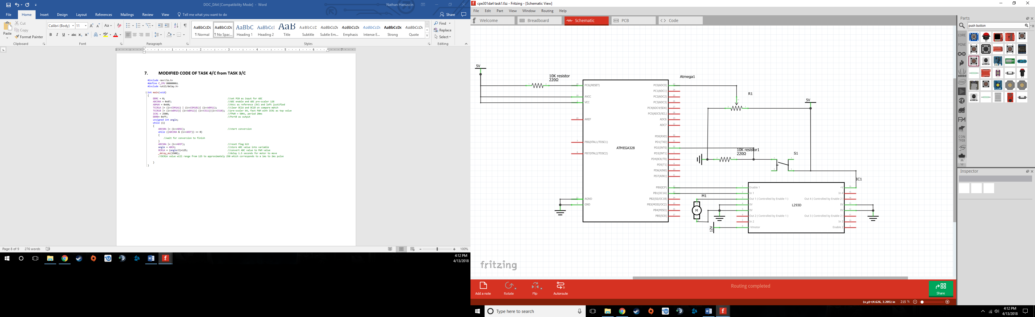Task 1 Schematic:

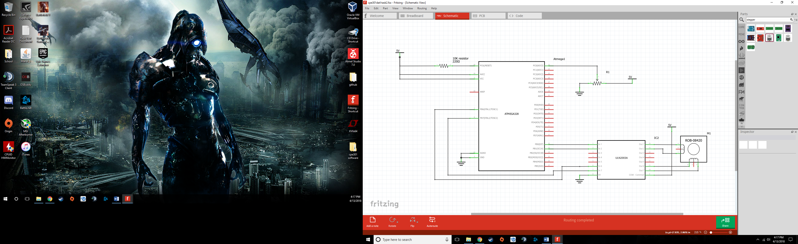Task 2 Schematic:

The stepper motor in my lab kit only has 4 control wires plus one for powering it and fritzing only has 6 lead stepper motors, so I ignored the center tapped wires.

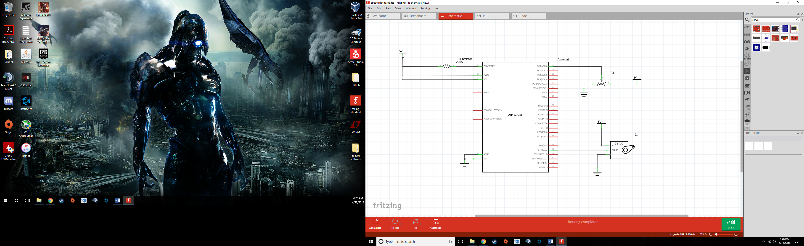Task 3 Schematic

1. **SCREENSHOTS OF EACH TASK OUTPUT (ATMEL STUDIO OUTPUT)**

Refer to videos for outputs

1. **SCREENSHOT OF EACH DEMO (BOARD SETUP)**

Task 1:

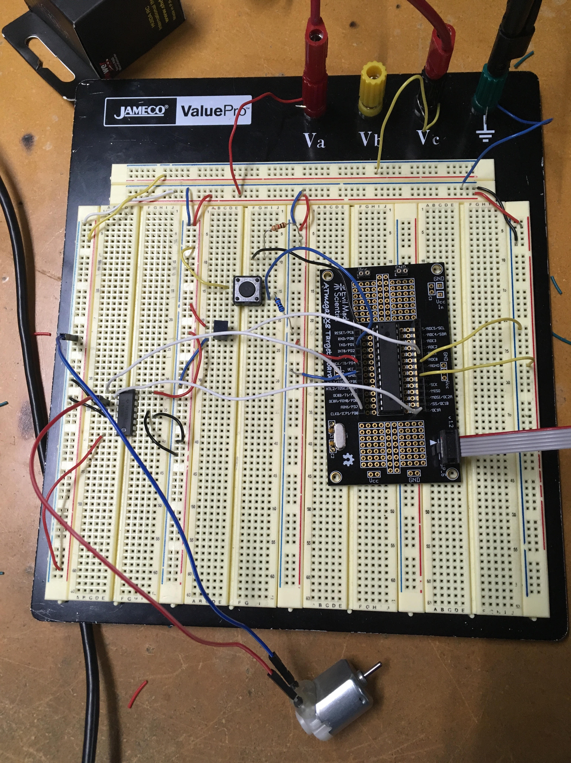

Task 2:

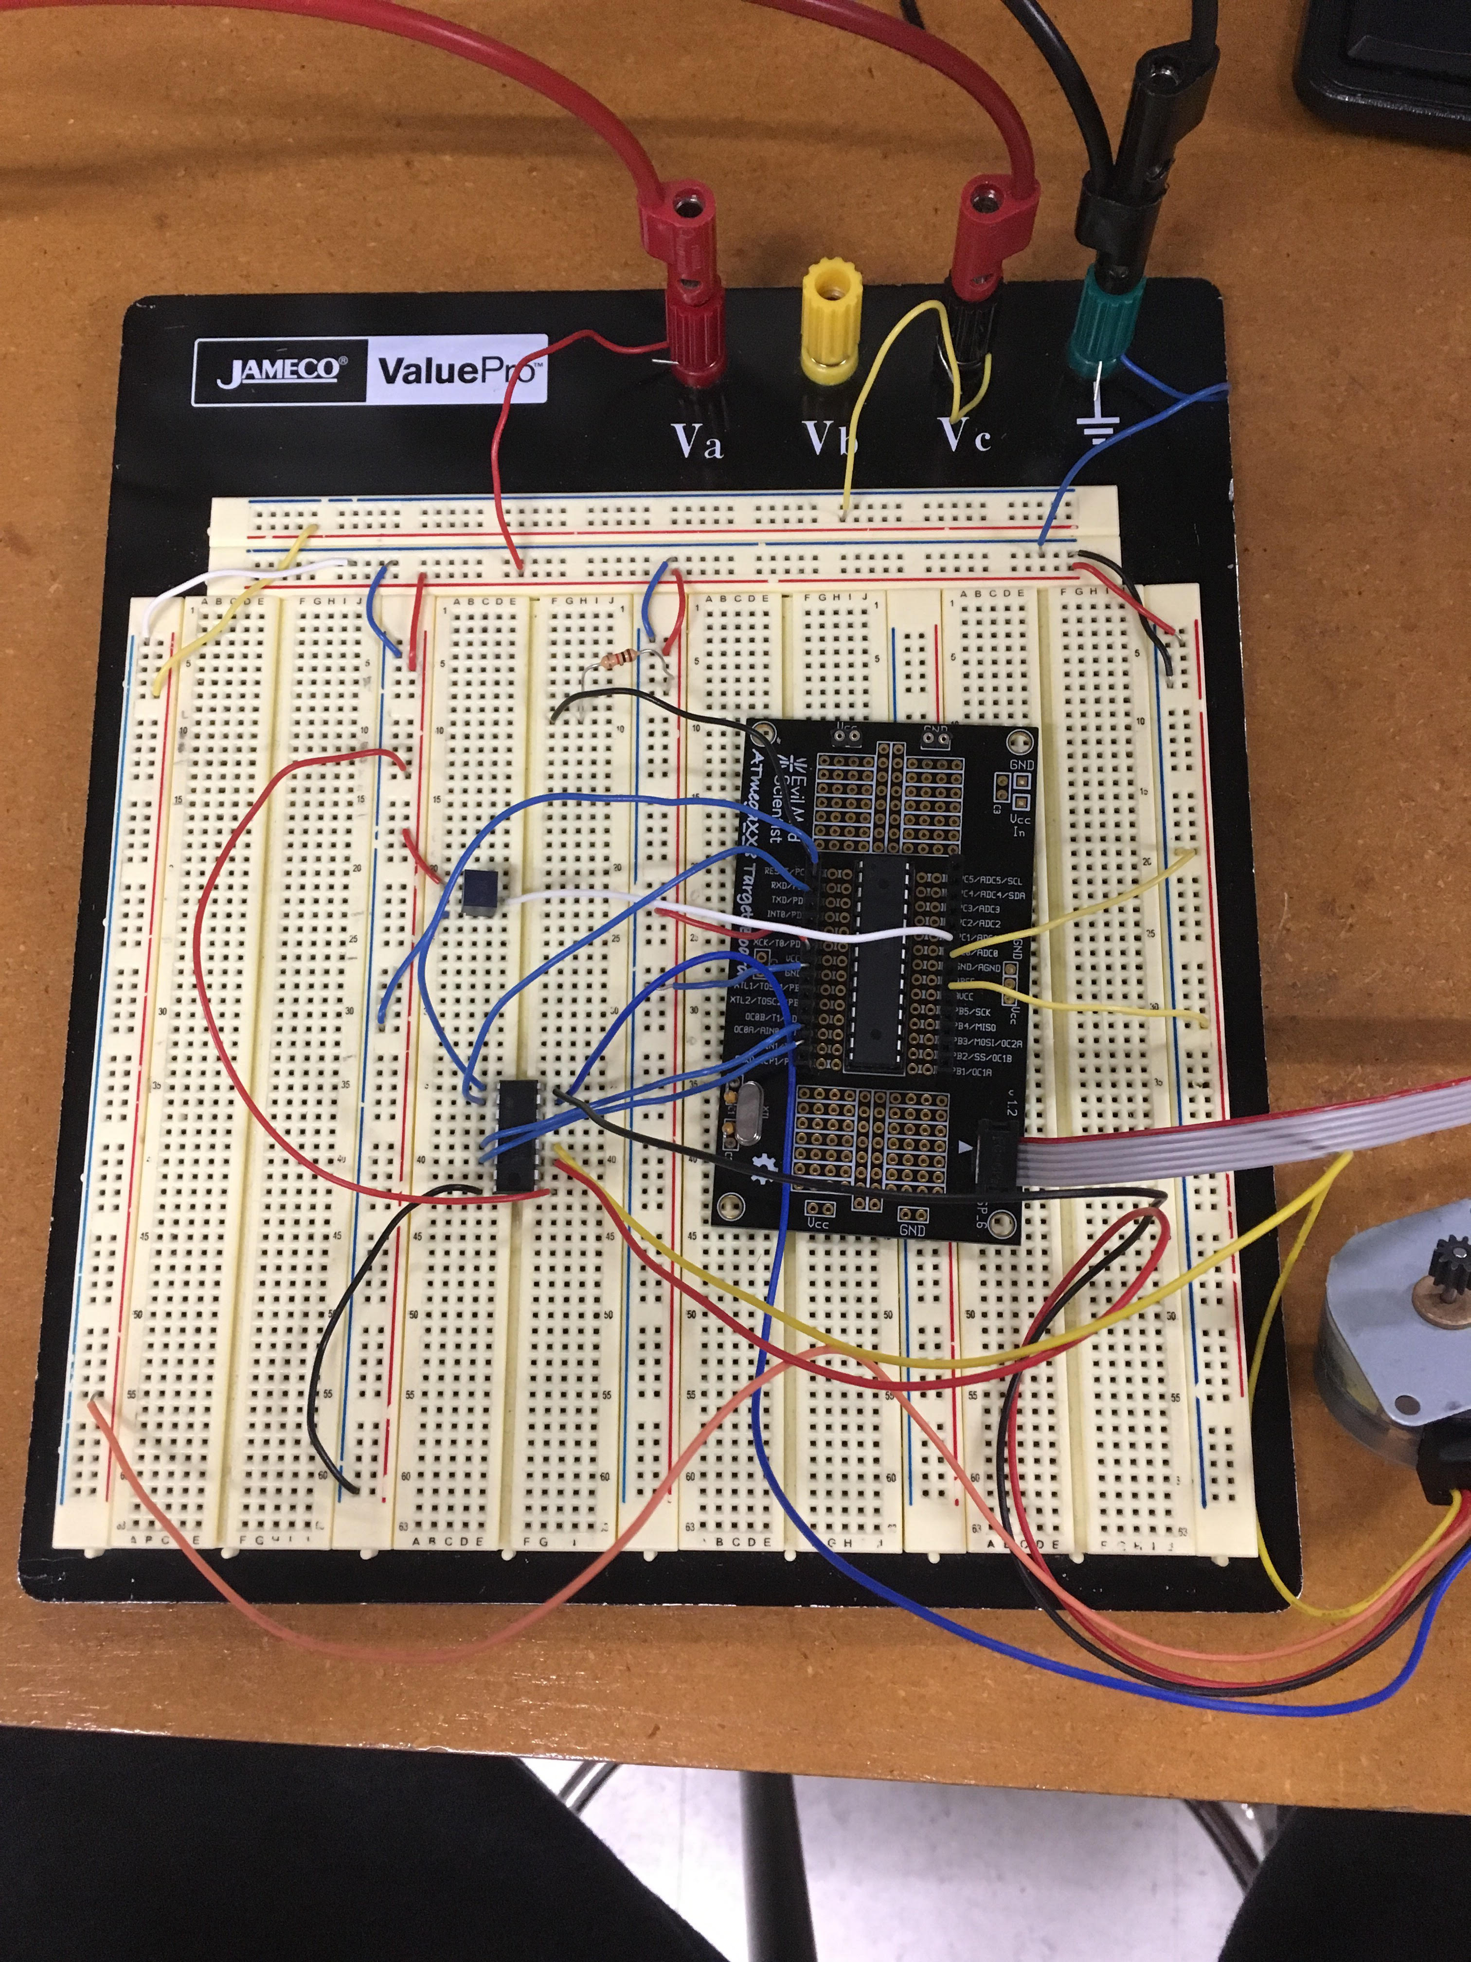

Task 3:

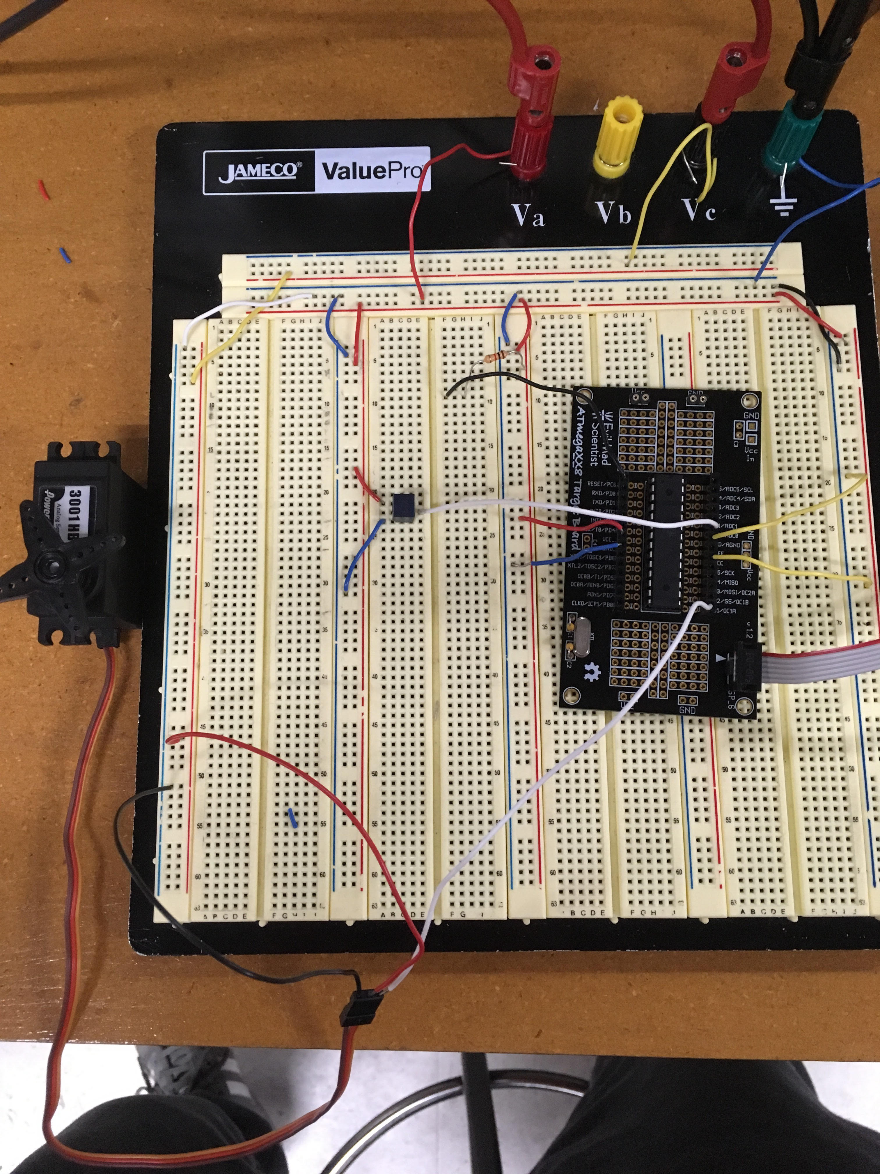

1. **VIDEO LINKS OF EACH DEMO**

Playlist - https://www.youtube.com/channel/UCX_dEuWexNMLRw5YqdTRQTg/playlists

Task1 - https://www.youtube.com/watch?v=C2g4so_71tw

Task2 - https://www.youtube.com/watch?v=7d5P36XGX1k

Task3- https://www.youtube.com/watch?v=fXSHr5Kn8aw

1. **GITHUB LINK OF THIS DA**

https://github.com/nhanuscin/submit/tree/master/DA4

**Student Academic Misconduct Policy**

<http://studentconduct.unlv.edu/misconduct/policy.html>

“This assignment submission is my own, original work”.

Nathan Hanuscin